Analyzing the structural effect of point mutations of Cytotoxic Necrotizing Factor 1 (CNF1) to Lu/BCAM Adhesion Glycoprotein association
Alexandre G. de Brevern

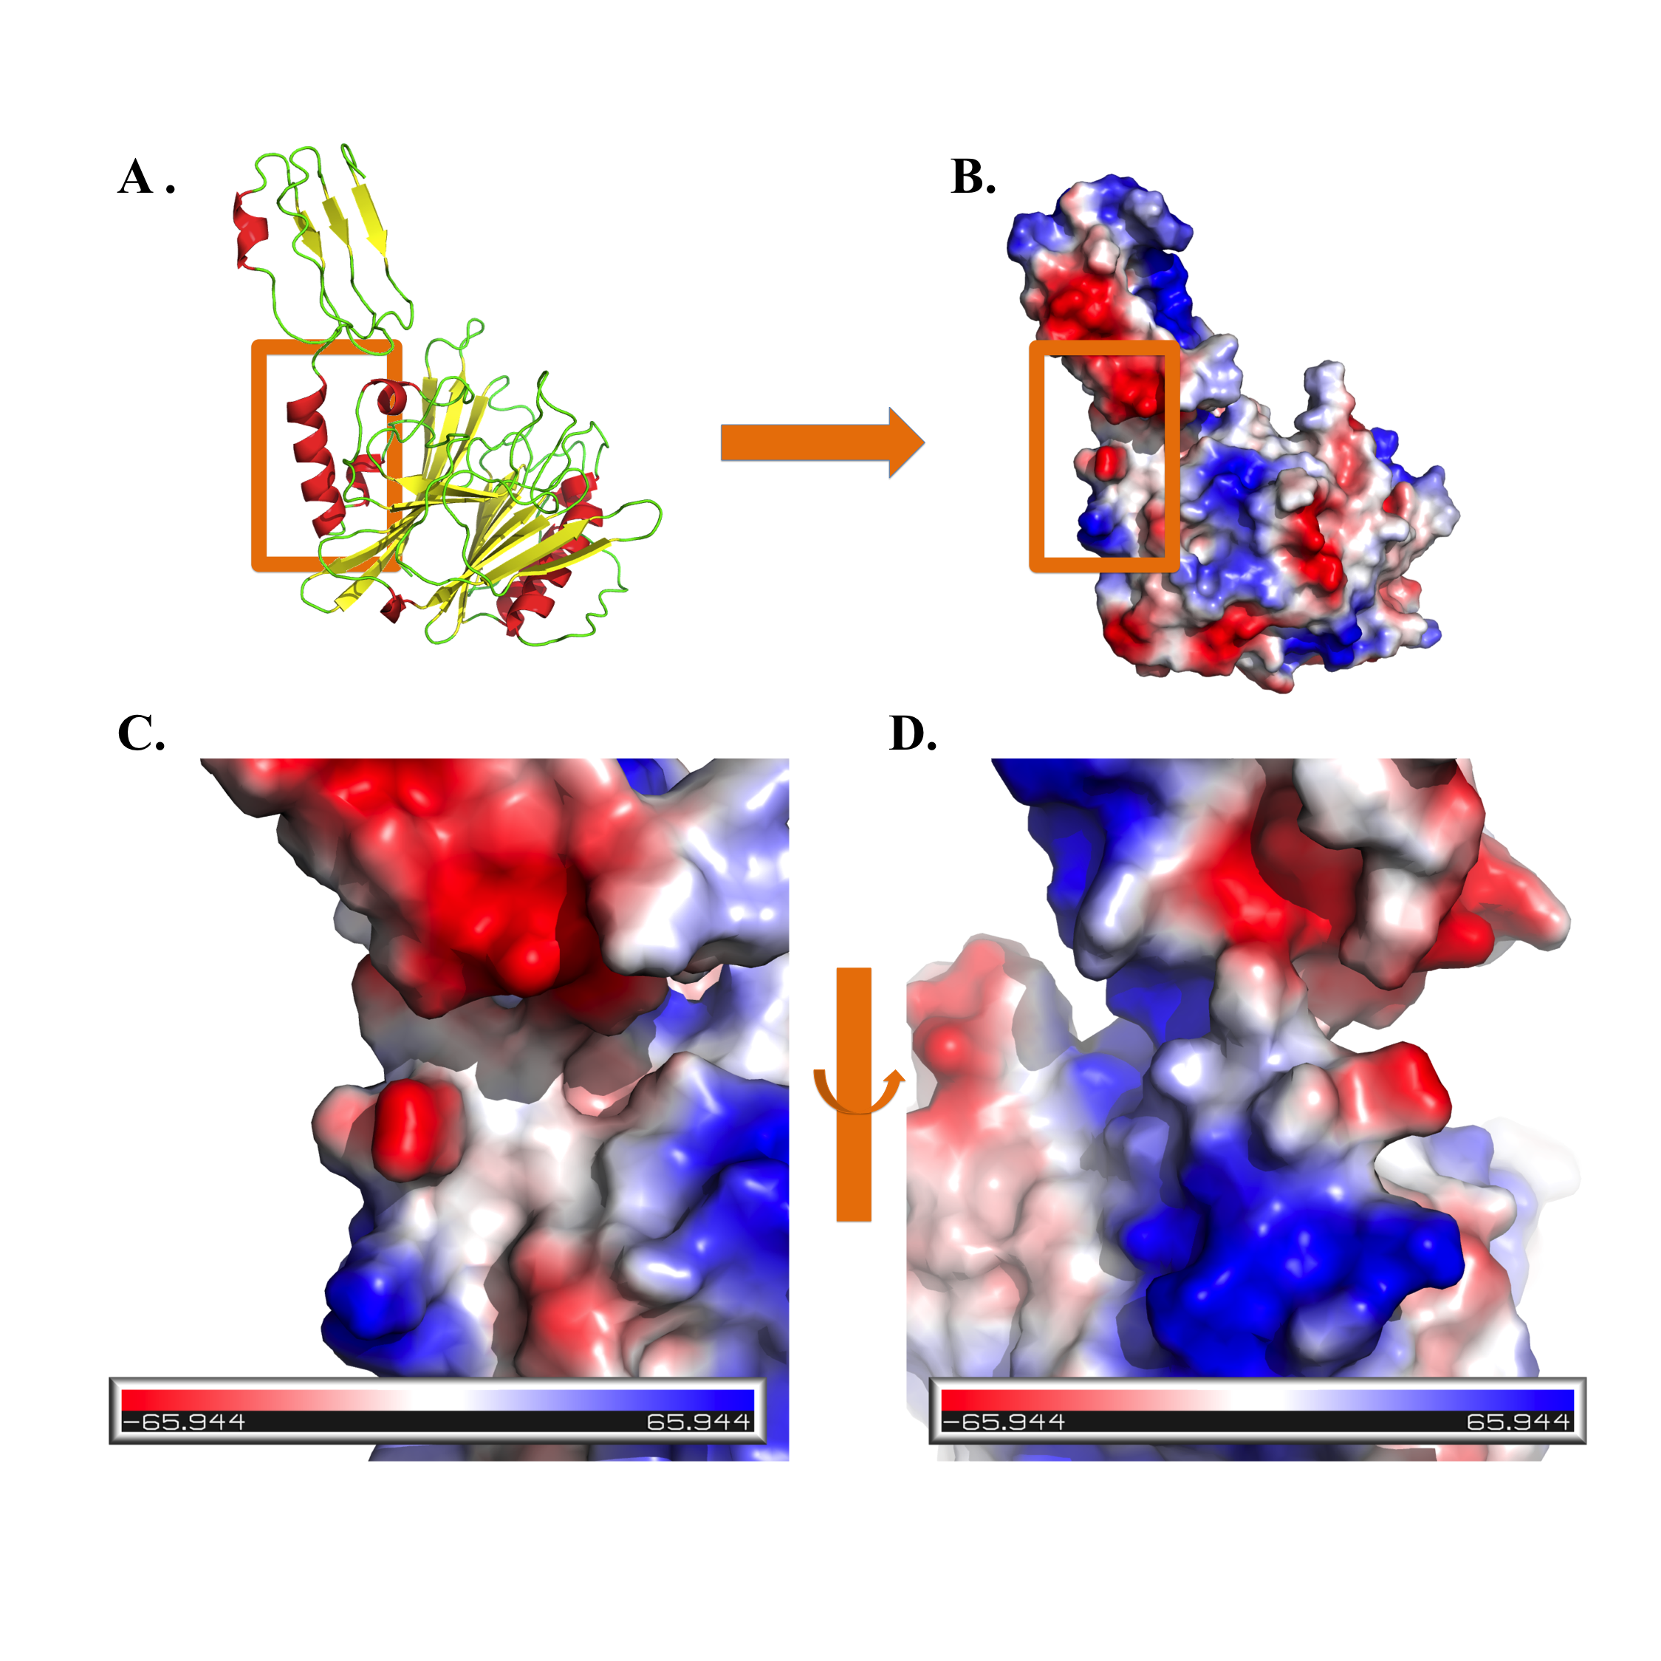
Figure S1. Structural model of wild type CNF1 657-1024 domain. (A). Cartoon representation. (B). Electrostatics visualisation. (C) & (D). Focus on the interaction region.

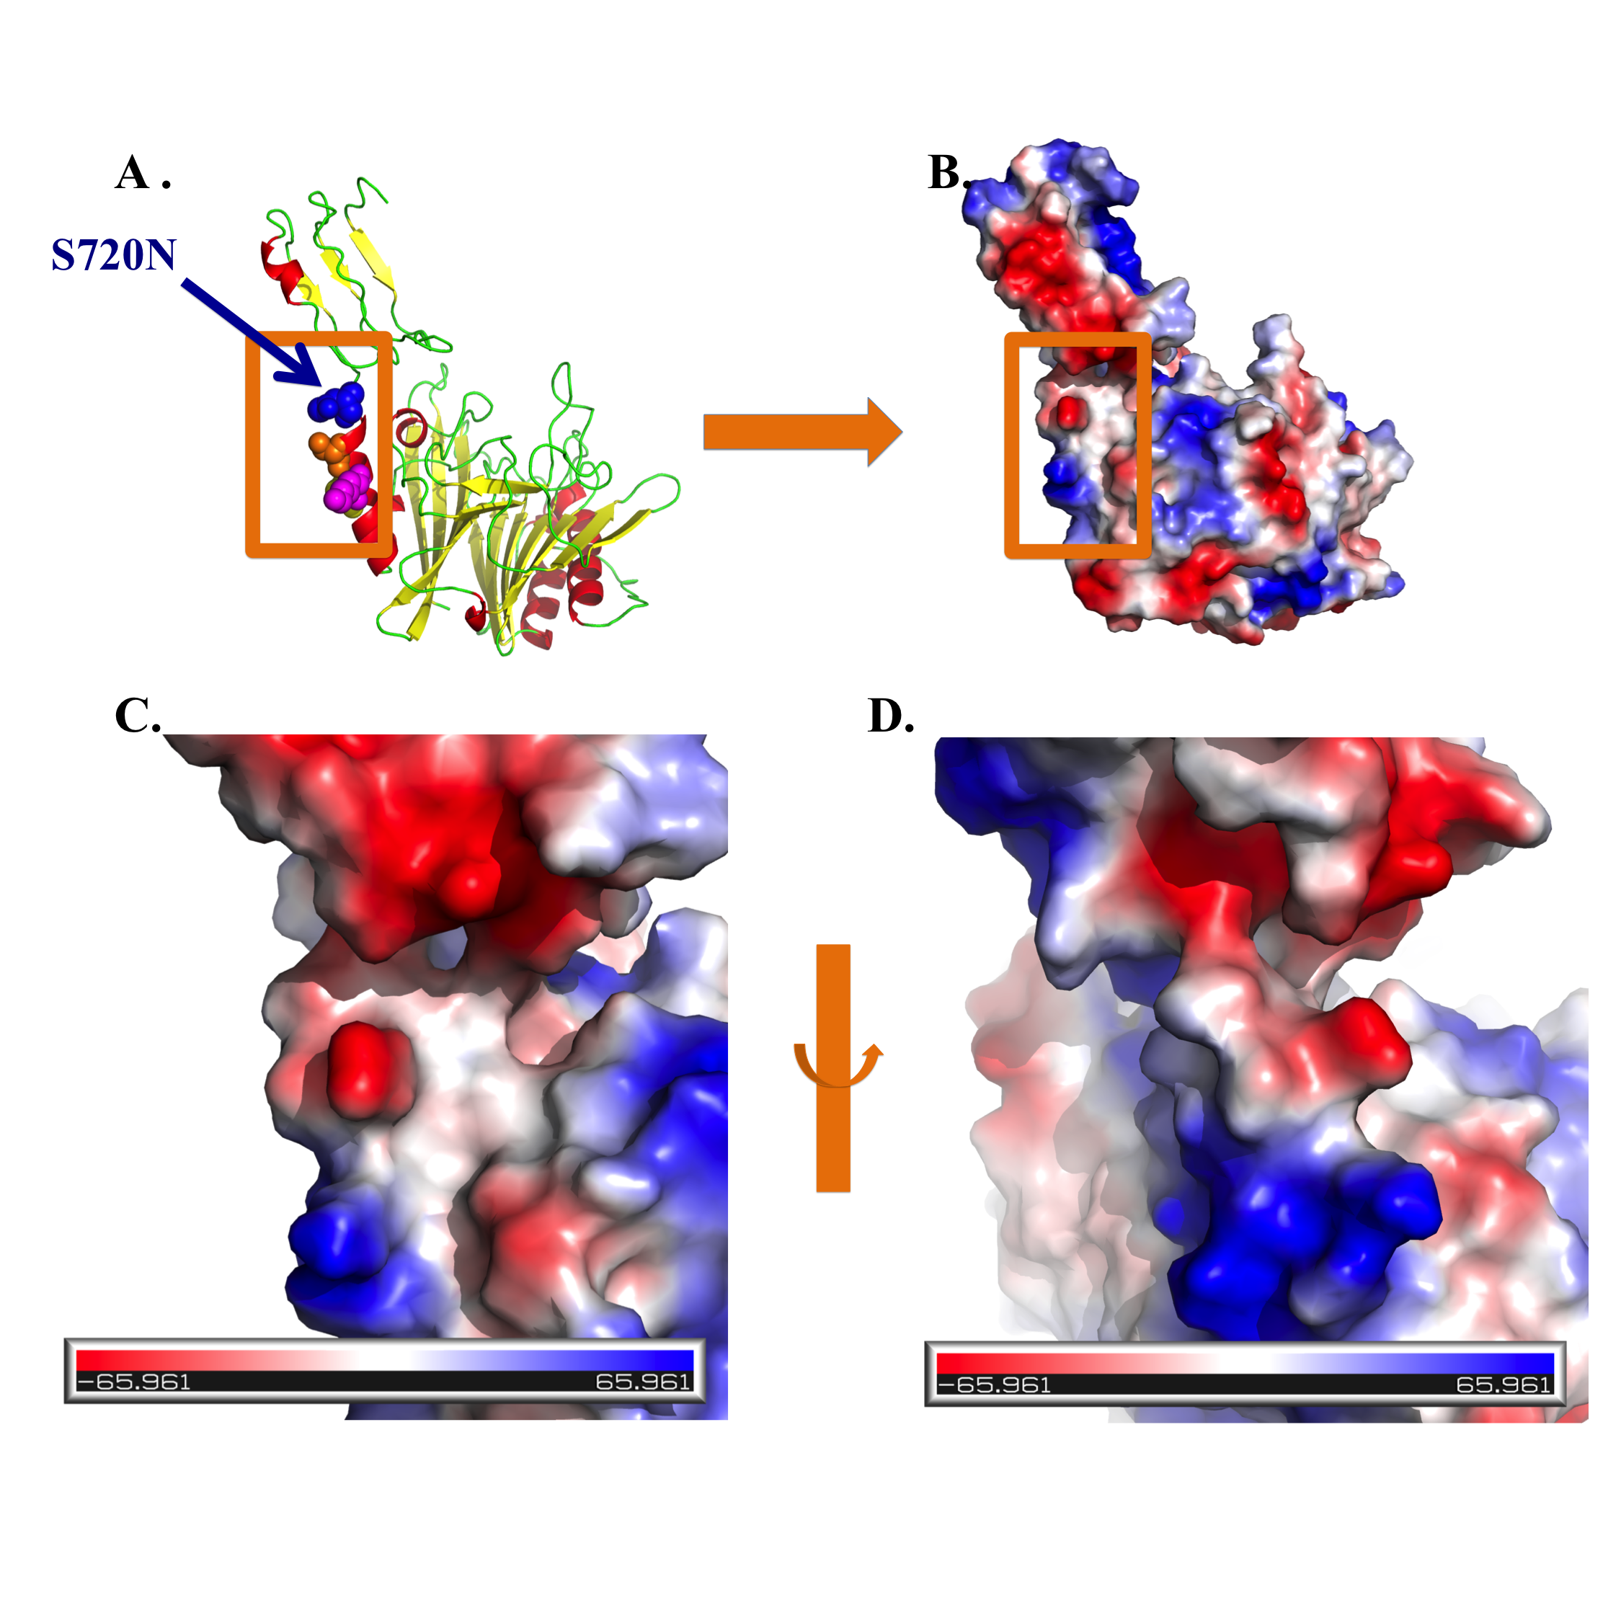
Figure S2. Structural model of mutant S720N of CNF1 657-1024 domain. (A). Cartoon representation. (B). Electrostatics visualisation. (C) & (D). Focus on the interaction region.

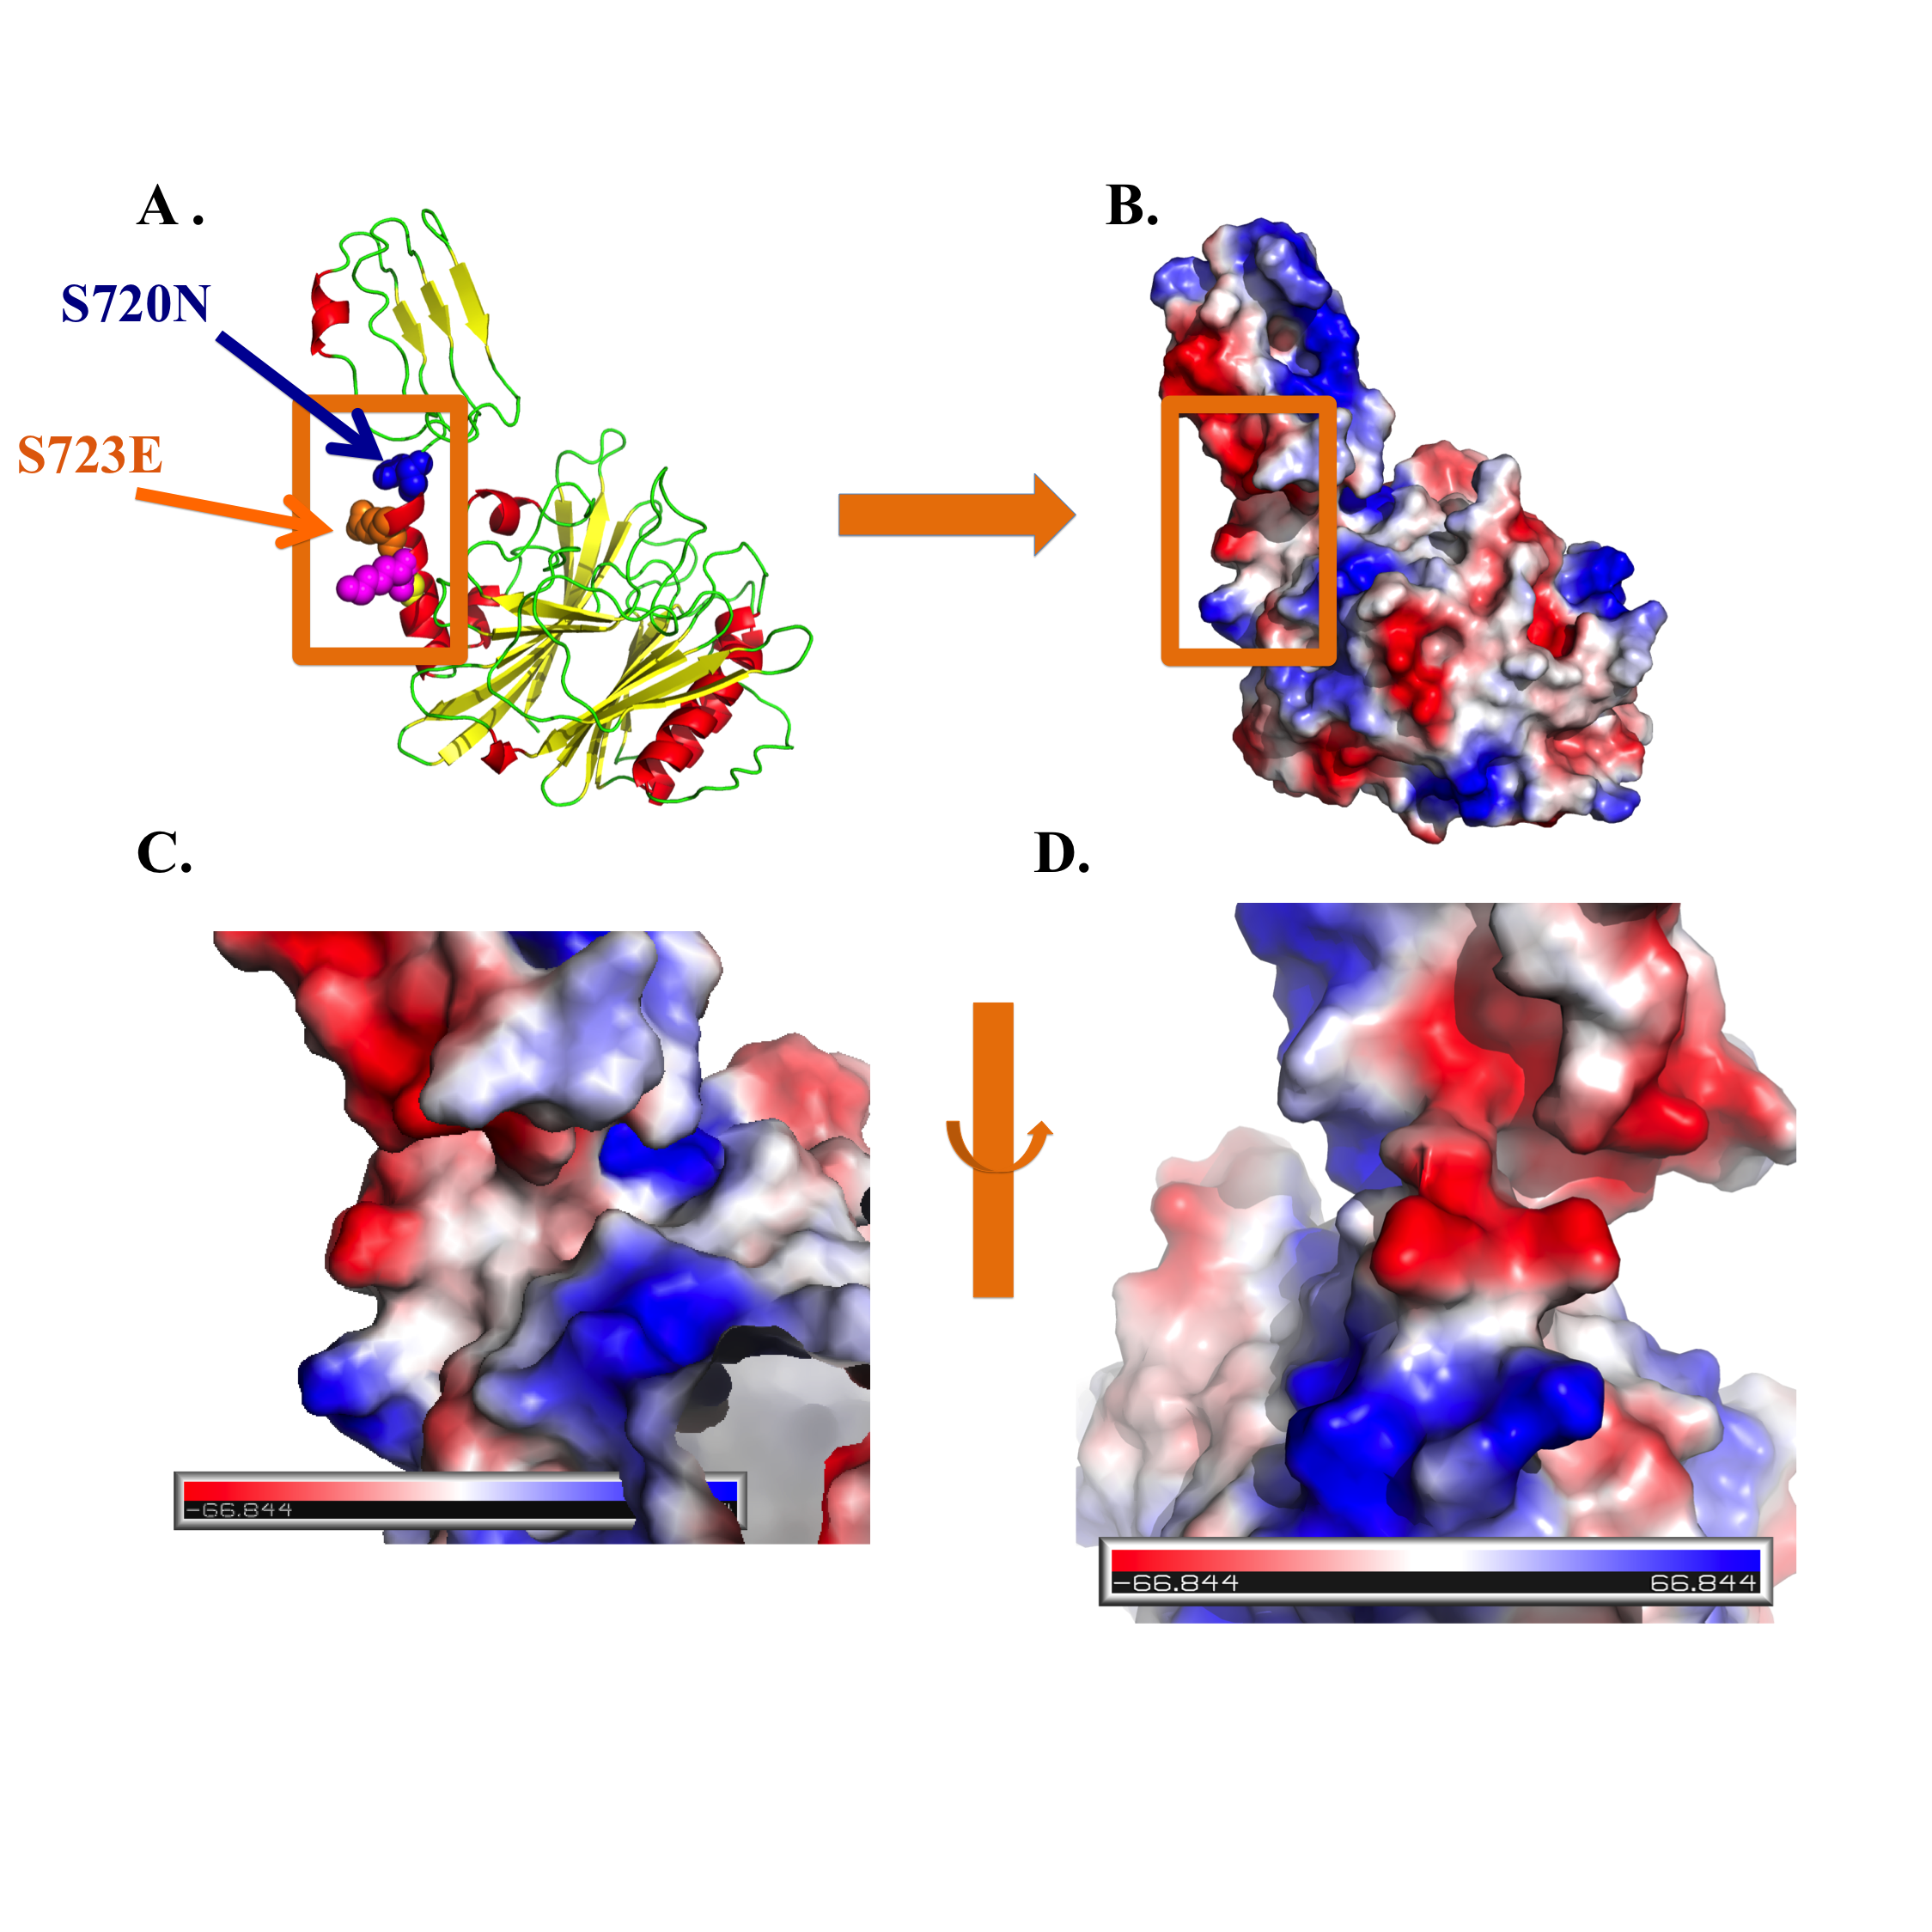
Figure S3. Structural model of double mutant S720N & S723E of CNF1 657-1024 domain. (A). Cartoon representation. (B). Electrostatics visualisation. (C) & (D). Focus on the interaction region.
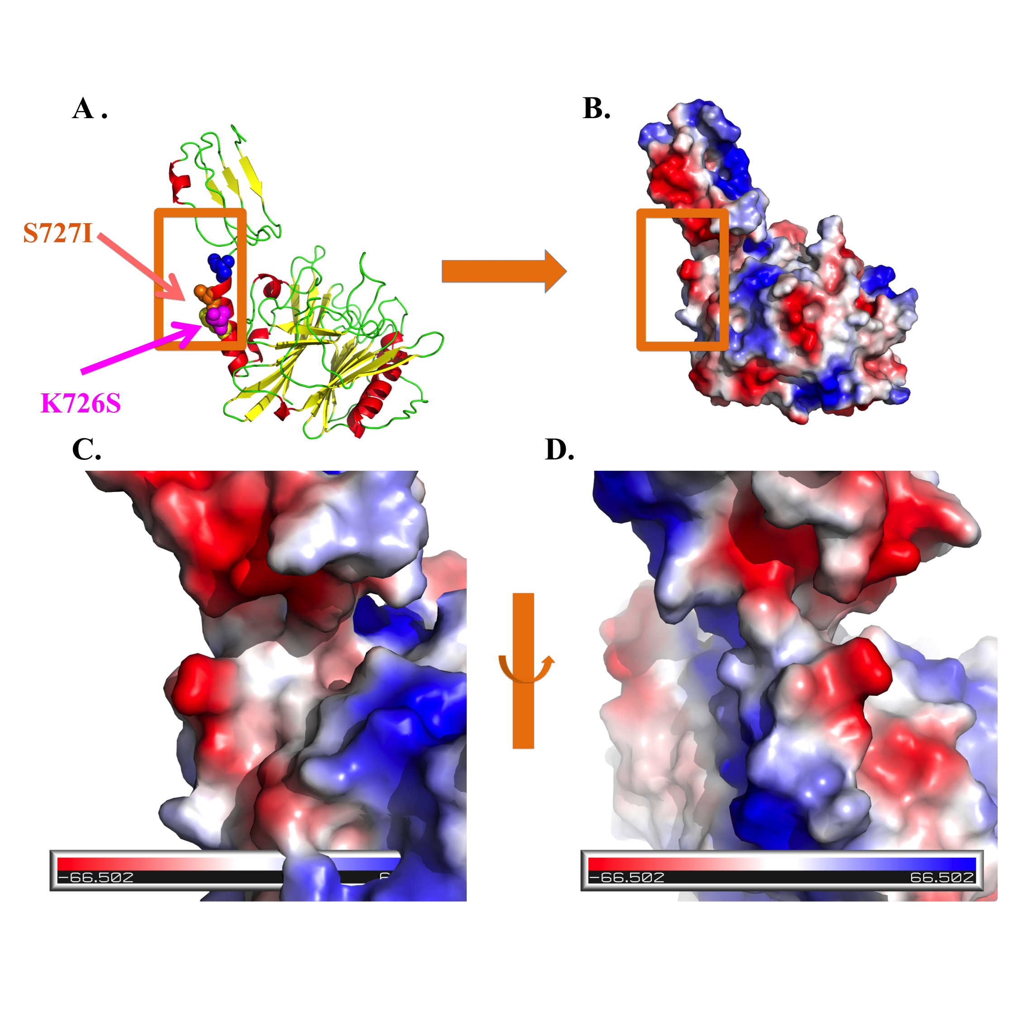
Figure S4. Structural model of double mutant K726S & S727I of CNF1 657-1024 domain. (A). Cartoon representation. (B). Electrostatics visualisation. (C) & (D). Focus on the interaction region.

