Supporting Information
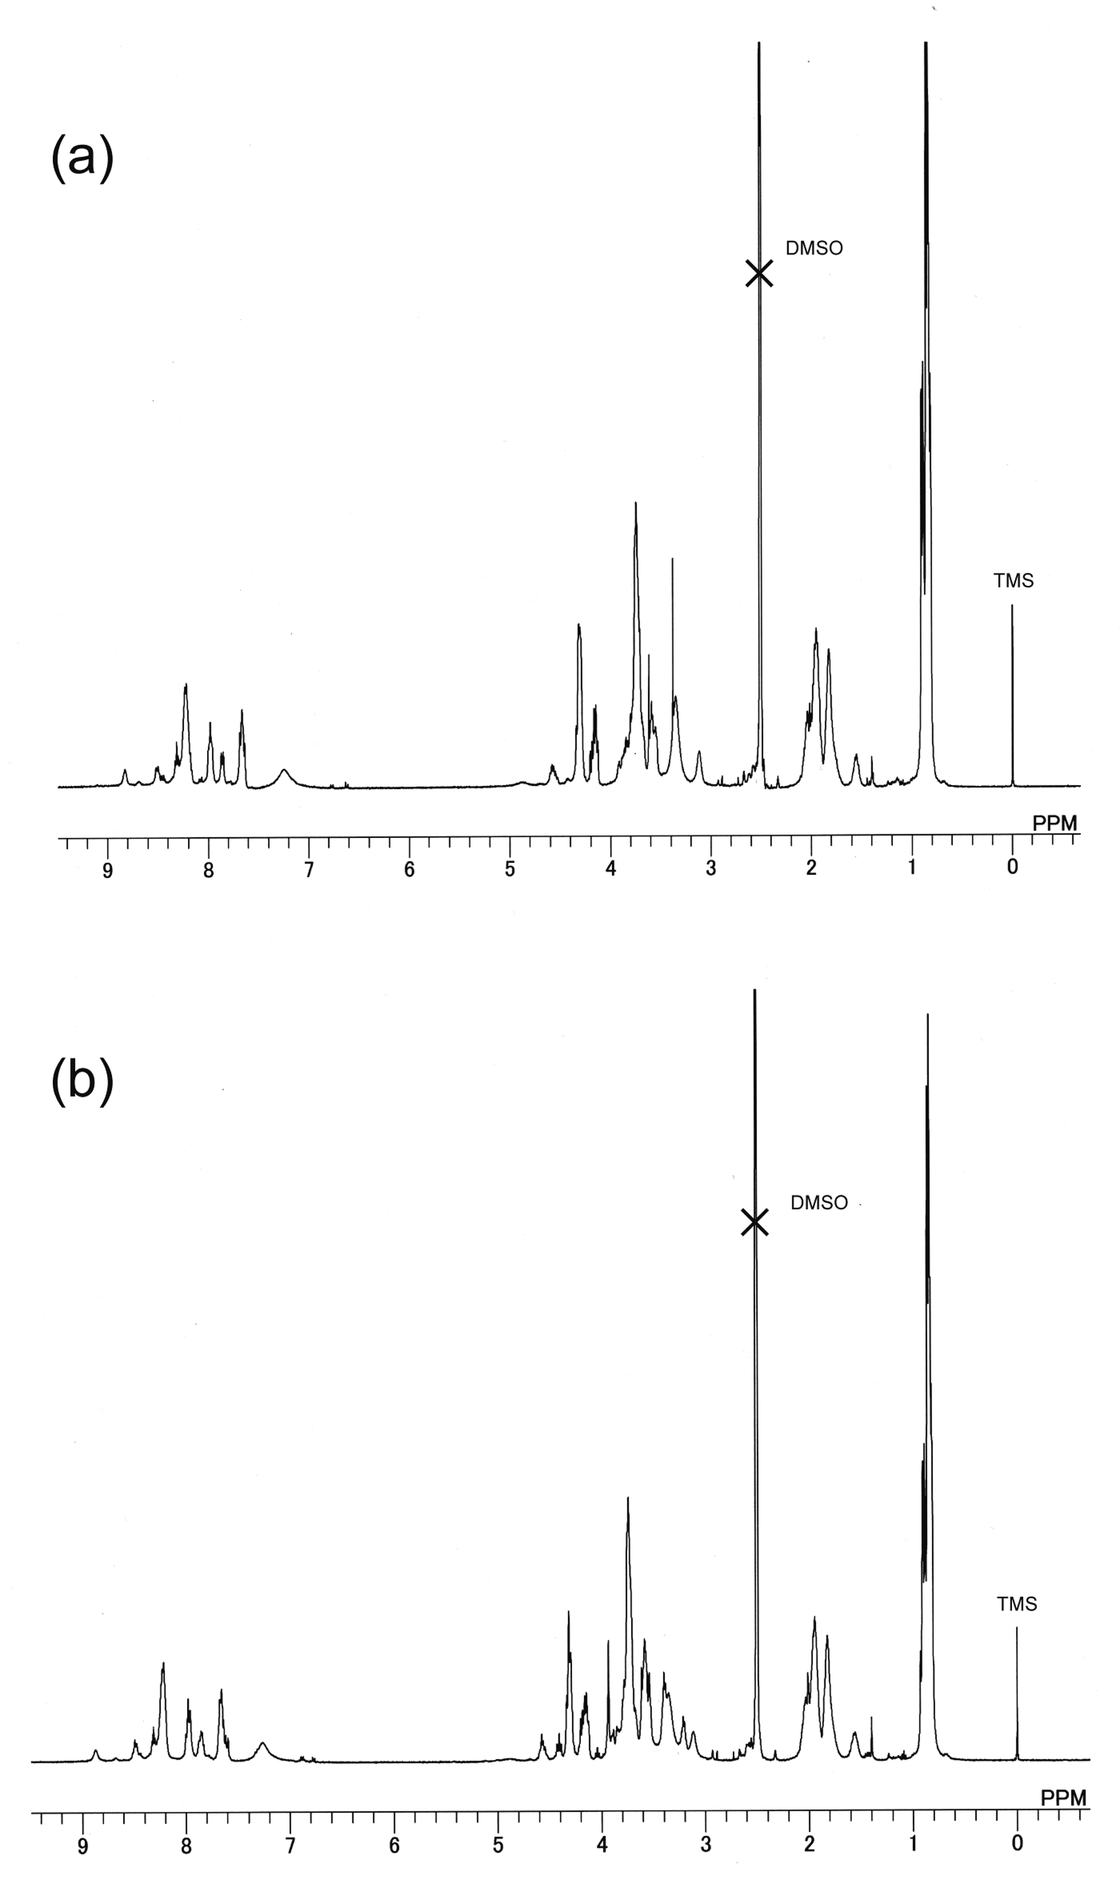
Figure S1. ¹H-NMR spectra of the RGDS-ELP (a) and RGDS-deg-ELP (b) in d₆-DMSO (TMS) at 20 °C.
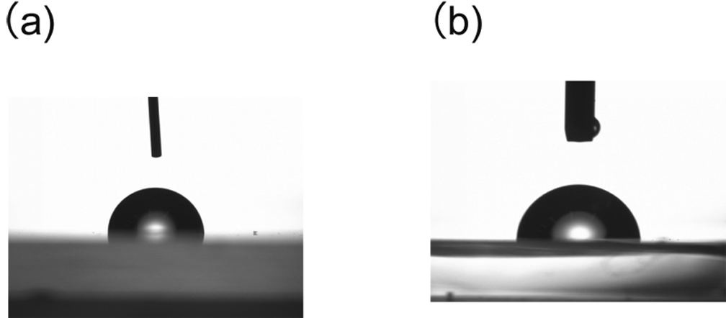
Figure S2. Water contact angles of the (a) RGDS-ELP-covered PSt-dish and
(b) RGDS-deg-ELP-covered PSt-dish.
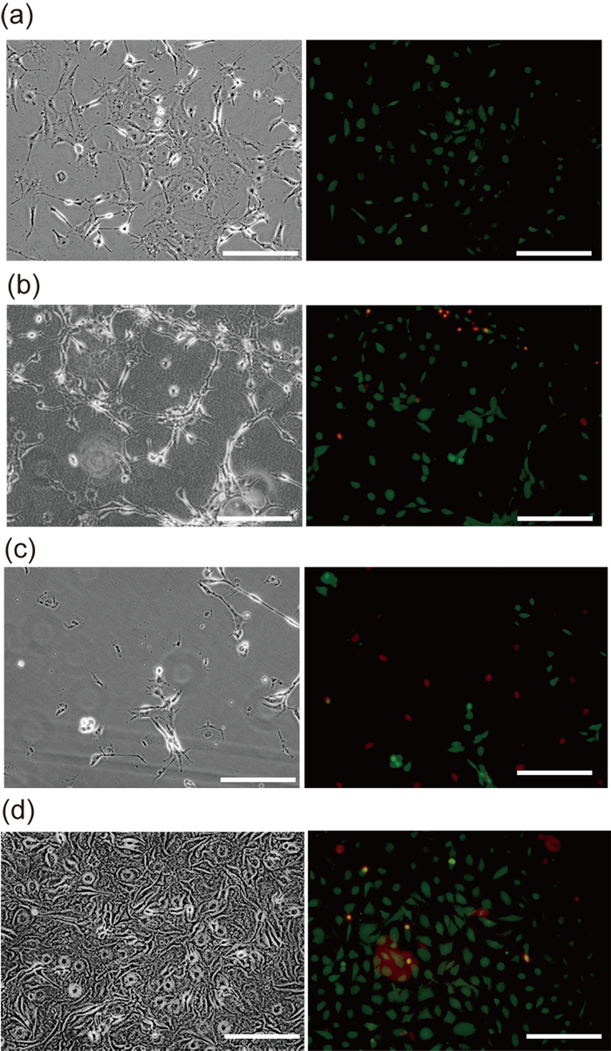
Figure S3. The live/dead cell assay of NIH/3T3 cells (1.0 × 10⁴ cells cm⁻²) cultured for 24 h on RGDS-deg-ELP-covered PSt-dish (a), RGDS-ELP-covered PSt-dish (b), bare PSt-dish (c) and tissue culture dish (BiocoatTM Fibronectin Cellware) (d). Left pictures: phase-contarast images, right pictures: merged fluorescence images. Calcein stain (green) identifies live cell, while EthD stain (red) identifies dead cells. Scale bar: 200 μm.
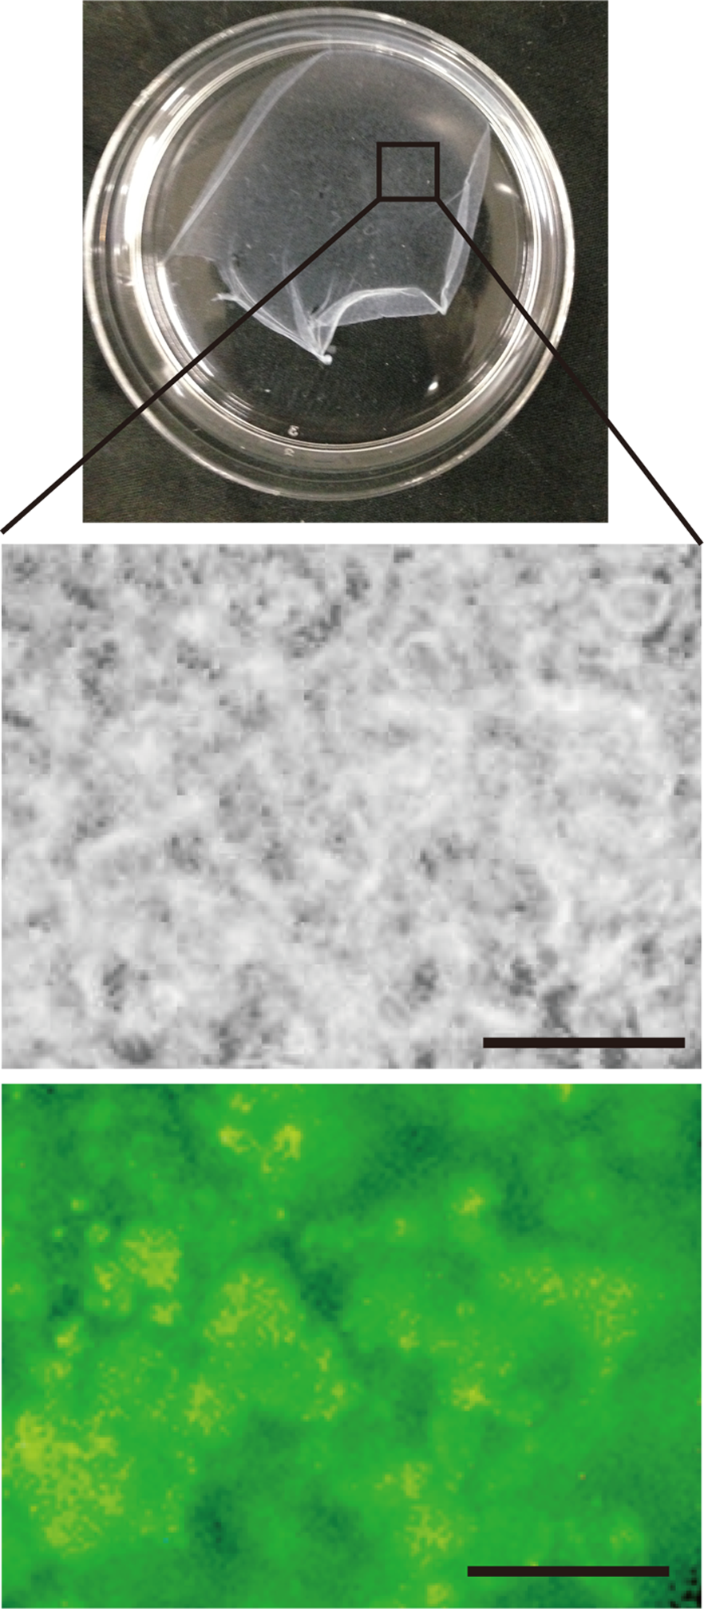
Figure S4. Phase-contrast and fluorescence images of the cell-sheet prepared on RGDS-ELP-covered PSt-dish. Calcein stain in fluorescence image (bottom) identifies live cell. Scale bar: 50 μm.

